Figure 1 - Available papers by year and country.
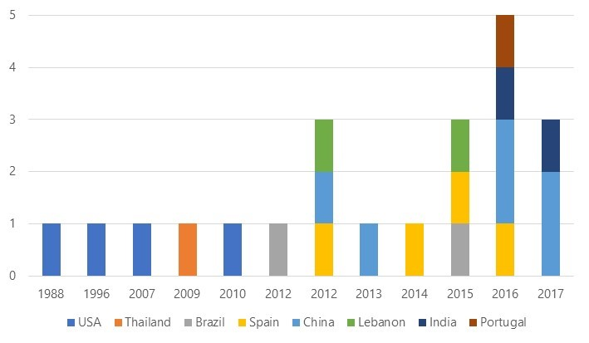
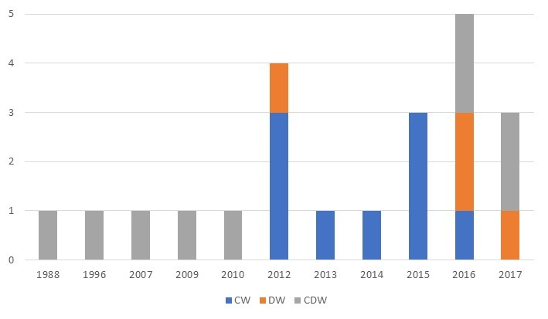
Figure 2 - Number of papers per year by waste evaluated type.

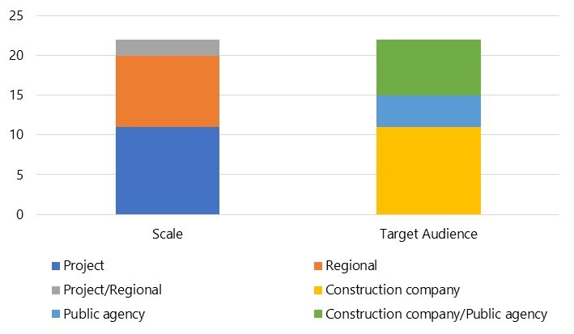
Figure 3 - Papers by scale and target audience of waste quantification equations.

Figure 4 - Papers by country classified by waste evaluated
