Figure 1. Localization of the city of Piedade do Paraopeba, Brazil.

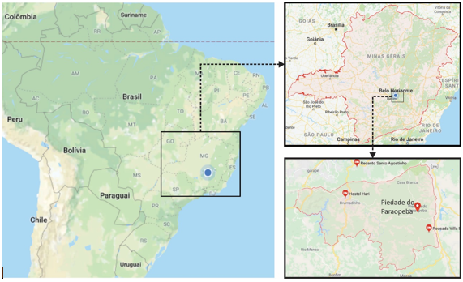

Source: Google Maps

Table 01:Emissivity coefficient of the main Construction Materials

|  |  |
| --- | --- |
| **Material** | **Ɛ** |
| Concrete | 0.94 |
| Sand | 0.76 |
| Gravel | 0.75 ... 0.80 |
| Plastic | 0.90 ... 0.96 |
| Glass | 0.90 ... 0.96 |
| Wood | 0.80 ... 0.90 |
| Ink | 0.90 ... 0.96 |

Source: Plesu et al. (2012).

Figure 2. Photo from the Mother Church of Nossa Senhora da Piedade do Paraopeba  
(a) in the beginning of 2000; (b) nowadays..

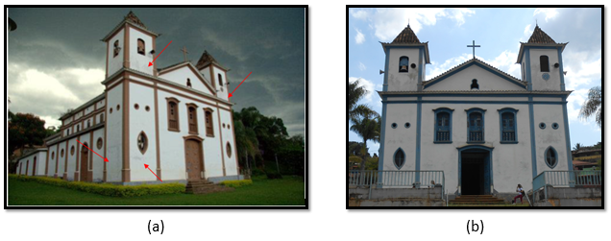

Source: Google and Authors ´collection

Figure 4. Frontal facade of Mother Church of Nossa Senhora da Piedade do Paraopeba.

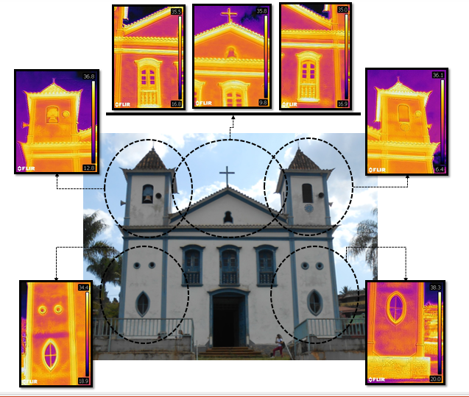

Source: Authors' collection

Figure 3. FLIR 450sc termal imager.



Source: FLIR, 2016

Figure 5. Fissures identified visually on the facade..

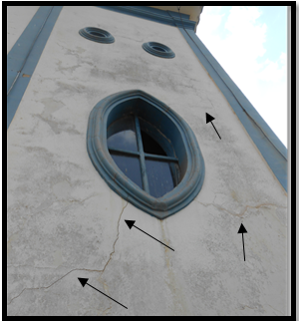

Source: Authors' collection

Figure 7. Right side of the Mother Church of Nossa Senhora da Piedade do Paraopeba.

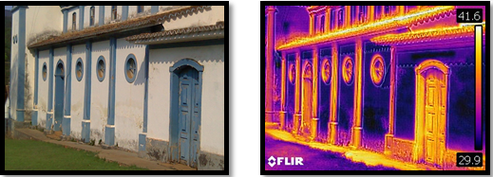

Source: Authors' collection

Figure 6. Right side of the Mother Church of Nossa Senhora da Piedade do Paraopeba.

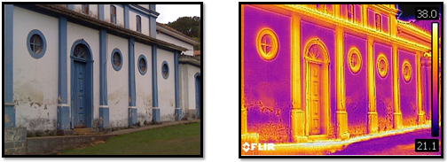

Source: Authors' collection

Figure 8. Left side of the Mother Church of Nossa Senhora da Piedade do Paraopeba.

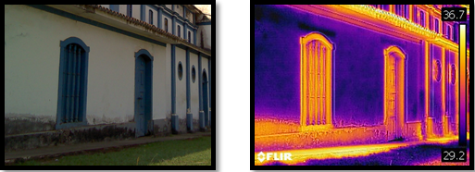

Source: Authors' collection

Figure 9. Left side of the Mother Church of Nossa Senhora da Piedade do Paraopeba.

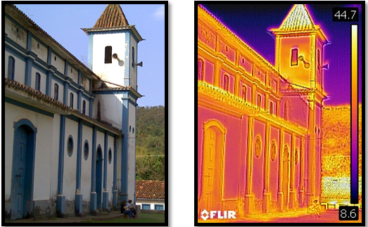

Source: Authors' collection

Figure 10. Left side of the Mother Church of Nossa Senhora da Piedade do Paraopeba.

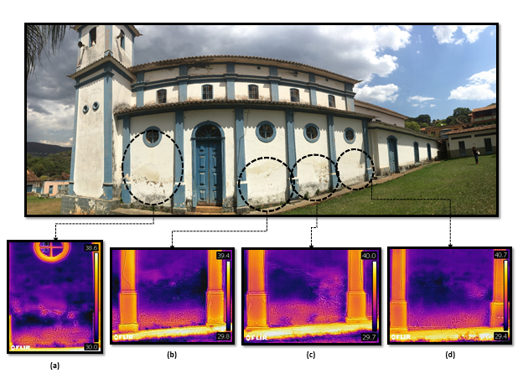

Source: Authors' collection

Figure 12. Left tower of the Mother Church of Nossa Senhora da Piedade do Paraopeba.

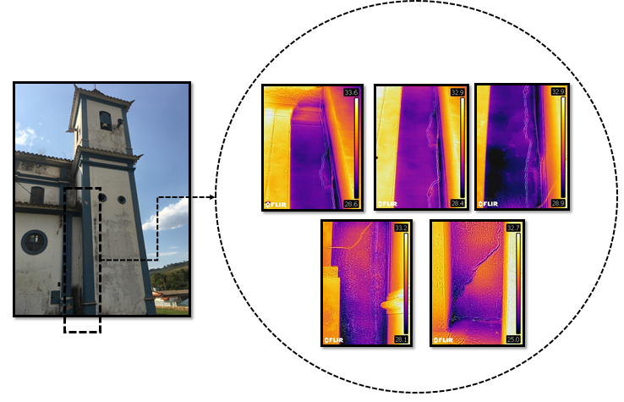

Source: Authors' collection

Figure 11. Areas of moisture concentration on the right side of the church.

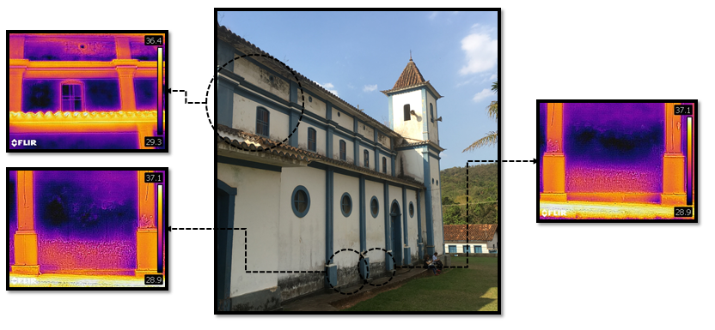

Source: Authors' collection

Figure 14. Coverage in the main hall of the Mother Church of Nossa Senhora da Piedade do Paraopeba.

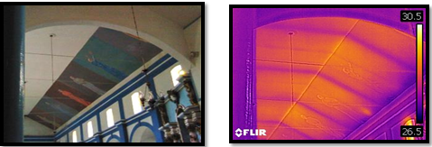

Source: Authors' collection

Figure 13. Main internal arch of the Mother Church of Nossa Senhora da Piedade do Paraopeba.

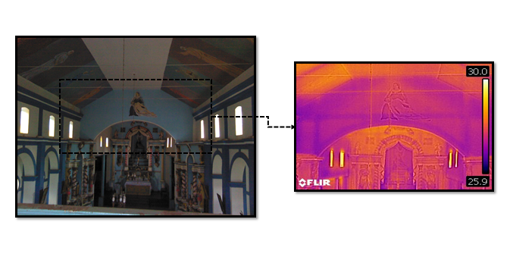

Source: Authors' collection

Figure 16. Left internal corridor of the Mother Church of Nossa Senhora da Piedade Paraopeba.

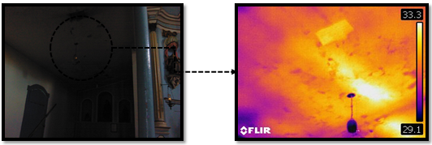

Source: Authors' collection

Figure 15. Right internal corridor of the Mother Church of Nossa Senhora da Piedade do Paraopeba.

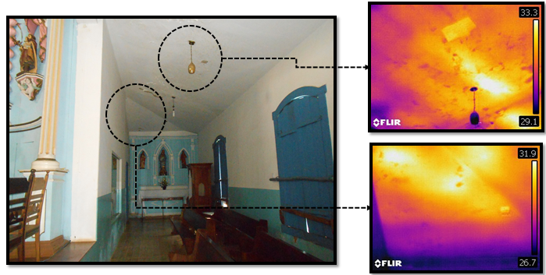

Source: Authors' collection